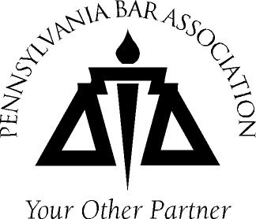
The 2009 Mid-Year Meetings are being presented in cooperation with the Pennsylvania Bar Institute (PBI). PBI is approved by the PA Supreme Court CLE Board as an accredited CLE provider. The program for the 2009 WIP Mid-Year Meetings has been approved for 2.0 hours CLE credits: 1 Substantive and 1 Ethics.

PBA Commission on Women in the Profession
2009 Harrisburg Mid-Year Meeting
Widener Law School’s Sidebar Cafe
3800 Vartan Way
March 11, 2009
11:00 a.m. – 2:30 p.m.
Registration Deadline: March 6, 2009

Registration Information

Name

Supreme Court ID

Name for Name Badge

Please check here if you require special services and attach a written description of your needs.

Program and Reception
I will be attending and: (Select one of the following):
I do not wish to receive CLE Credit for the program. Cost: $0.00

I do want to receive CLE Credit for the program. Cost: $50.00

Payment Information: Payment for CLE registration must accompany the registration form. No phone reservations will be accepted.

My check made payable to “PBA” is enclosed for the CLE Credits.

OR Charge my: Master Card VISA AMEX Discover

Credit Card #: Expiration Date

3-digit security code (VISA & MC only)

Authorized Amount $ Signature:

No cost and credit card registrations can be sent to Audrey Perez via FAX to 717-213-2545 or email to: Audrey.perez@pabar.org
Or enclose your check and mail with your completed registration form to Audrey at:
PBA Meetings Department
P.O. Box 186
Harrisburg, PA 17108-0186

Questions - Contact Emily Lewis at 1-800-932-0311 ext. 2206

